Sediment Trap Summary

2024-12-05

This report provides summary tables and figures for the sediment trap data at Tampa Bay and Caloosahatchee River stations from December 2022 through November 2024.  
  
Monthly data is standardized to a 28-day month unless otherwise noted.  
  
Overall values are based on all data summarizes together. Data is extrapolated to the entire sample collected in most cases. Columns including “Sample” in the title are from crucible data and not extrapolated to the entire sample collected.

Table 1. Sedimentation rates (g/month) by station and overall during the project. Rates are standardized to 28-day months.

| **Estuary** | **Station** | **MeanRate** | **sdRate** | **MinRate** | **MaxRate** |
| --- | --- | --- | --- | --- | --- |
| CR |  |  |  |  |  |
|  | 1 | 75.85 | 61.83 | 12.45 | 348.70 |
|  | 2 | 58.46 | 91.70 | 0.66 | 522.68 |
|  | 3 | 45.52 | 124.07 | 2.80 | 563.52 |
|  | 4 | 93.72 | 82.98 | 3.41 | 393.91 |
|  |  | 68.85 | 93.01 | 0.66 | 563.52 |
| TB |  |  |  |  |  |
|  | 1 | 433.70 | 347.56 | 40.41 | 1,081.46 |
|  | 4 | 44.70 | 63.70 | 7.84 | 376.96 |
|  | 5 | 15.47 | 10.80 | 2.90 | 40.37 |
|  | 6 | 98.93 | 144.48 | 9.65 | 665.19 |
|  | 7 | 137.27 | 244.55 | 19.40 | 1,100.90 |
|  | 8 | 18.95 | 15.80 | 0.32 | 63.95 |
|  |  | 126.03 | 234.50 | 0.32 | 1,100.90 |

Table 2. Percent organic content (%) by station and overall during the project. Sample columns use crucible level data while other columns extrapolate measurements to the entire sample based on calculated proportions.

| **Estuary** | **Station** | **MeanPct** | **sdPct** | **MinPct** | **MaxPct** | **MeanSample** | **sdSample** | **MinSample** | **MaxSample** |
| --- | --- | --- | --- | --- | --- | --- | --- | --- | --- |
| CR |  |  |  |  |  |  |  |  |  |
|  | 1 | 19.28 | 21.52 | 0.00 | 97.11 | 65.62 | 25.18 | 2.54 | 99.28 |
|  | 2 | 14.18 | 15.84 | 0.00 | 54.78 | 45.23 | 29.67 | 0.98 | 94.80 |
|  | 3 | 12.94 | 9.78 | 2.11 | 32.13 | 33.40 | 26.83 | 4.44 | 97.21 |
|  | 4 | 13.58 | 13.32 | 0.00 | 44.00 | 65.35 | 22.97 | 0.00 | 95.25 |
|  |  | 15.01 | 15.84 | 0.00 | 97.11 | 52.75 | 29.38 | 0.00 | 99.28 |
| TB |  |  |  |  |  |  |  |  |  |
|  | 1 | 23.25 | 24.81 | 0.00 | 80.83 | 87.40 | 13.41 | 52.26 | 98.29 |
|  | 4 | 23.47 | 18.98 | 0.00 | 78.91 | 55.38 | 25.32 | 9.16 | 94.25 |
|  | 5 | 23.40 | 18.79 | 0.00 | 56.18 | 40.98 | 20.80 | 11.01 | 74.03 |
|  | 6 | 22.92 | 20.59 | 0.00 | 77.83 | 68.86 | 20.87 | 17.33 | 95.32 |
|  | 7 | 14.92 | 17.35 | 0.00 | 78.82 | 68.32 | 18.69 | 29.68 | 97.17 |
|  | 8 | 39.50 | 20.39 | 0.14 | 76.20 | 60.10 | 22.24 | 24.90 | 94.76 |
|  |  | 24.28 | 21.24 | 0.00 | 80.83 | 63.49 | 24.86 | 9.16 | 98.29 |

Table 3. Organic weight (g/day) of sediment by station and overall during the project. Sample columns use crucible level data while other columns extrapolate measurements to the entire sample based on calculated proportions. Values are standardized to 28-day months.

| **Estuary** | **Station** | **MeanWt** | **sdWt** | **MinWt** | **MaxWt** | **MeanSample** | **sdSample** | **MinSample** | **MaxSample** |
| --- | --- | --- | --- | --- | --- | --- | --- | --- | --- |
| CR |  |  |  |  |  |  |  |  |  |
|  | 1 | 14.73 | 23.15 | 0.00 | 95.72 | 58.67 | 61.95 | 0.64 | 330.87 |
|  | 2 | 6.90 | 12.75 | 0.00 | 59.26 | 40.42 | 89.61 | 0.08 | 495.49 |
|  | 3 | 3.16 | 5.53 | 0.19 | 21.82 | 34.59 | 121.43 | 0.19 | 547.80 |
|  | 4 | 12.24 | 18.58 | 0.00 | 102.62 | 73.63 | 81.28 | 0.00 | 374.33 |
|  |  | 9.37 | 16.94 | 0.00 | 97.11 | 52.75 | 29.38 | 0.00 | 99.28 |
| TB |  |  |  |  |  |  |  |  |  |
|  | 1 | 102.46 | 191.97 | 0.00 | 825.86 | 408.79 | 343.06 | 21.12 | 1,055.90 |
|  | 4 | 8.55 | 9.96 | 0.00 | 51.63 | 32.33 | 60.87 | 1.21 | 355.28 |
|  | 5 | 3.10 | 3.44 | 0.00 | 18.38 | 6.68 | 6.58 | 0.62 | 28.50 |
|  | 6 | 16.67 | 24.09 | 0.00 | 100.21 | 83.43 | 138.25 | 3.19 | 634.09 |
|  | 7 | 11.22 | 13.30 | 0.00 | 48.09 | 114.64 | 242.29 | 6.60 | 1,067.76 |
|  | 8 | 7.19 | 9.38 | 0.02 | 38.18 | 13.41 | 14.35 | 0.18 | 60.60 |
|  |  | 25.05 | 86.28 | 0.00 | 80.83 | 63.49 | 24.86 | 9.16 | 98.29 |

Table 4. Minimum and maximum sedimentation rates, percent organic content, and organic weight per station and the Month and Year in which the minimum or maximum occurred.

| **Measure** | **Estuary** | **Station** | **Type** | **Year** | **Month** | **Value** |
| --- | --- | --- | --- | --- | --- | --- |
| Organic Weight | CR | 1 | Min Percent | 2024 | 09 | 0.84 |
| Max Percent | 2024 | 11 | 3.39 |
| 2 | Min Percent | 2024 | 06 | 0.56 |
| Max Percent | 2024 | 10 | 5.93 |
| 3 | Min Percent | 2024 | 06 | 0.41 |
| Max Percent | 2024 | 10 | 21.62 |
| 4 | Min Percent | 2024 | 06 | 2.37 |
| Max Percent | 2024 | 10 | 21.11 |
| TB | 1 | Min Percent | 2024 | 05 | 2.57 |
| Max Percent | 2024 | 07 | 11.32 |
| 4 | Min Percent | 2024 | 05 | 0.00 |
| Max Percent | 2024 | 08 | 14.97 |
| 5 | Min Percent | 2024 | 05 | 0.00 |
| Max Percent | 2024 | 06 | 1.90 |
| 6 | Min Percent | 2024 | 05 | 0.00 |
| Max Percent | 2024 | 08 | 13.77 |
| 7 | Min Percent | 2024 | 05 | 0.00 |
| Max Percent | 2024 | 08 | 29.78 |
| 8 | Min Percent | 2024 | 05 | 0.06 |
| Max Percent | 2024 | 08 | 7.73 |
| Percent Organic | CR | 1 | Min Percent | 2024 | 09 | 2.16 |
| Max Percent | 2024 | 07 | 7.33 |
| 2 | Min Percent | 2024 | 10 | 1.23 |
| Max Percent | 2024 | 07 | 7.94 |
| 3 | Min Percent | 2024 | 08 | 2.20 |
| Max Percent | 2024 | 06 | 7.64 |
| 4 | Min Percent | 2024 | 11 | 3.25 |
| Max Percent | 2024 | 08 | 7.49 |
| TB | 1 | Min Percent | 2024 | 05 | 0.39 |
| Max Percent | 2024 | 07 | 12.56 |
| 4 | Min Percent | 2024 | 05 | 0.00 |
| Max Percent | 2024 | 09 | 15.29 |
| 5 | Min Percent | 2024 | 05 | 0.00 |
| Max Percent | 2024 | 07 | 10.30 |
| 6 | Min Percent | 2024 | 05 | 0.00 |
| Max Percent | 2024 | 07 | 14.12 |
| 7 | Min Percent | 2024 | 05 | 0.00 |
| Max Percent | 2024 | 08 | 2.71 |
| 8 | Min Percent | 2024 | 05 | 0.30 |
| Max Percent | 2024 | 06 | 22.27 |
| Sedimentation | CR | 1 | Min Rate | 2024 | 01 | 15.49 |
| Max Rate | 2023 | 12 | 202.14 |
| 2 | Min Rate | 2024 | 06 | 15.94 |
| Max Rate | 2024 | 10 | 438.89 |
| 3 | Min Rate | 2024 | 03 | 2.85 |
| Max Rate | 2024 | 10 | 553.50 |
| 4 | Min Rate | 2024 | 01 | 16.56 |
| Max Rate | 2024 | 10 | 341.23 |
| TB | 1 | Min Rate | 2023 | 08 | 49.52 |
| Max Rate | 2024 | 03 | 1,041.99 |
| 4 | Min Rate | 2024 | 01 | 8.07 |
| Max Rate | 2024 | 08 | 278.98 |
| 5 | Min Rate | 2024 | 01 | 3.11 |
| Max Rate | 2023 | 09 | 35.33 |
| 6 | Min Rate | 2023 | 07 | 11.11 |
| Max Rate | 2024 | 08 | 586.78 |
| 7 | Min Rate | 2023 | 12 | 23.13 |
| Max Rate | 2024 | 08 | 1,099.68 |
| 8 | Min Rate | 2024 | 01 | 2.43 |
| Max Rate | 2023 | 07 | 46.95 |

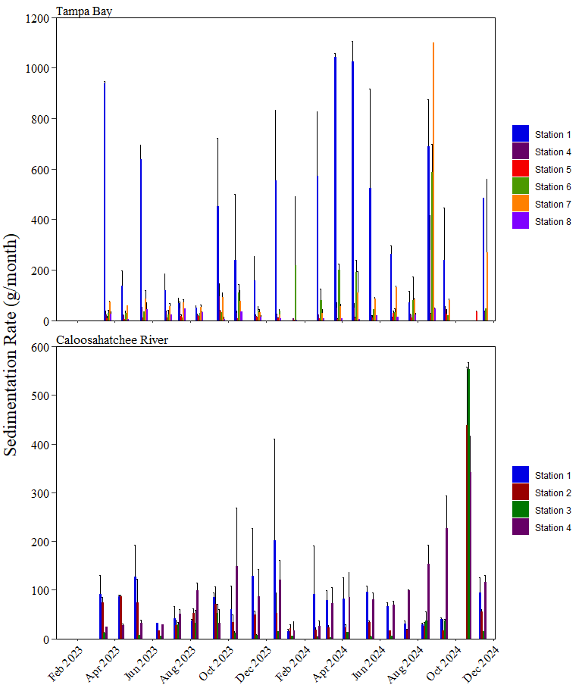

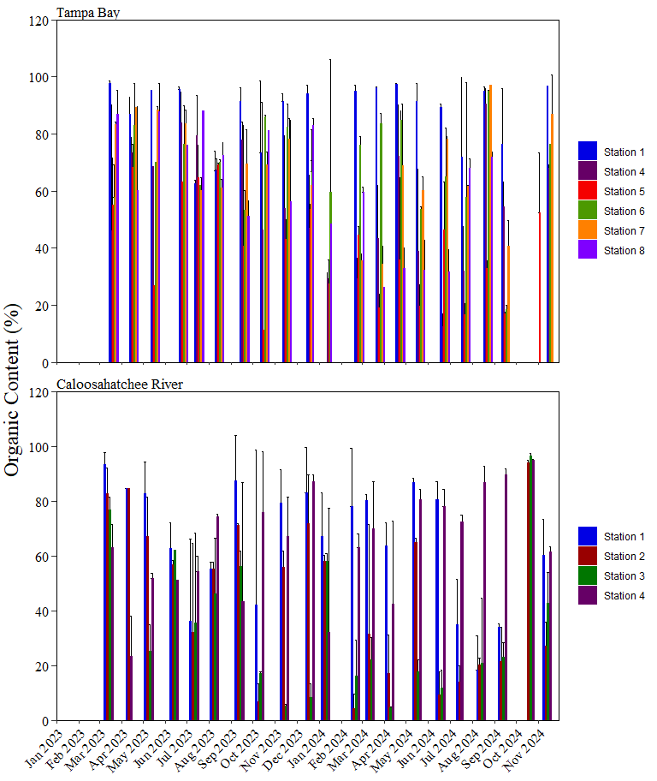

**Figure 2.** Monthly organic content (%) of sediment at stations in Tampa Bay and Caloosahatchee River. Values are based on crucible samples. Asterisks indicate when no samples were collected from a station.

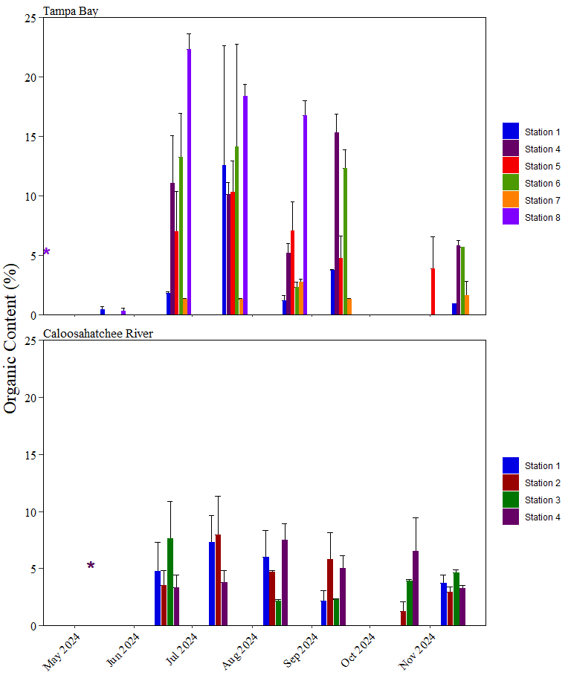

**Figure 3.** Monthly organic content (%) of sediment at stations in Tampa Bay and Caloosahatchee River. Values are extrapolated to the entire samples. Asterisks indicate when no samples were collected from a station.